Indoor Wi-Fi Positioning System Using RSSI Fingerprint Matching
Murala Preethishivani
Department of software enginerring
Cleveland State University
Cleveland,OH,USA
2886813@vikes.csuohio.edu

Nandini Tupakula
Department of computer science
Cleveland State University
Cleveland,OH,USA
2887786@vikes.csuohio.edu
Sahithi Reddy Alamgari
Department of computer science
Cleveland State University
Cleveland,OH,USA
2894909@vikes.csuohio.edu

ABSTRACT
This paper presents an indoor positioning system that leverages Wi-Fi signal fingerprinting as an alternative to GPS for location detection in indoor environments. The system relies on collecting and comparing signal strength (RSSI) and network identifiers (BSSID) from Wi-Fi access points to determine a user’s physical location inside a building. Data is captured using standard network commands, stored in JSON format, and compared using a distance-based algorithm implemented with a Flask-based web application. The project demonstrates room-level location accuracy using only existing infrastructure and lightweight browser interaction, offering potential for low-cost, scalable indoor tracking solutions.
KEYWORDS
Indoor Positioning, Wi-Fi Fingerprinting, RSSI, BSSID, Flask, Localization, Room Detection
1 INTRODUCTION
Location-aware services are increasingly important for applications such as navigation, asset tracking, and user analytics. While GPS provides accurate global location data, it becomes unreliable or unavailable in indoor environments due to signal blockage by walls and ceilings. This creates a need for indoor positioning systems (IPS) based on existing infrastructure such as Wi-Fi networks.
This project explores a lightweight Wi-Fi-based indoor positioning solution that relies on signal fingerprinting. The core idea is that the strength and identity of Wi-Fi access points vary by physical location. By collecting signal fingerprints from each room in a building and storing them, we can compare new scans against this database to estimate the device’s current location.
Our system enables a user to submit live Wi-Fi scan data through a web browser. The server compares it to pre-recorded fingerprints using a simple RSSI distance metric and returns the closest match as the predicted room. This paper outlines the design, algorithm, testing, and results of the project.

2 SYSTEM DESIGN
2.1 Architecture Overview
The system is designed with modular components for easy deployment and future enhancement. It includes:
- Frontend Web Interface: Built using HTML, CSS, and Jinja templating.
- Backend Server: Flask handles user input and response logic.
- Wi-Fi Data Collection: Done using netsh commands on Windows laptops.
- Fingerprint Database: Stored as JSON files, each corresponding to a room.
- Matching Engine: A Python function that calculates similarity between scan input and stored data.

📍 Flowchart of the System
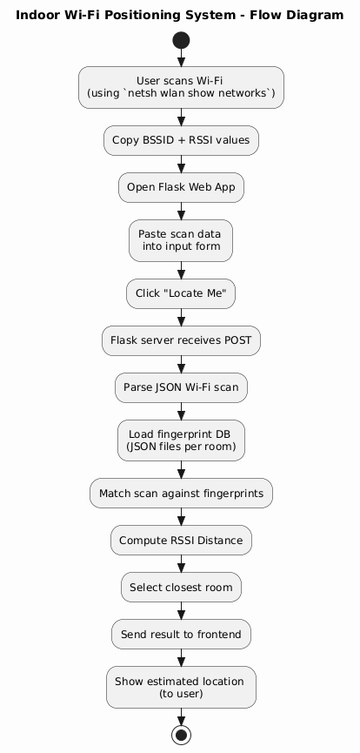

2.2 Data Collection Method
Data was collected using a Windows laptop and the following command:
---
netsh wlan show networks mode=bssid
This command returns a list of visible Wi-Fi networks including:
- SSID (Network Name)
- BSSID (MAC address of the router)
- RSSI (Signal strength in percentage)
From each room (301 to 308), both inside and outside, multiple scans were performed. Each scan result was saved in a JSON file with format:
-------
[
{
"SSID": "CSUwireless",
"BSSID": "38:90:a5:90:02:4c",
"RSSI": 89
},
{
"SSID": "CSUwireless",
"BSSID": "38:90:a5:90:2b:0c",
"RSSI": 35
},
{
"SSID": "CSUwireless",
"BSSID": "38:90:a5:90:03:83",
"RSSI": 34
}, ...
]
Over 200 samples were collected per location for robustness.

📸 Screenshot 1 – netsh Wi-Fi Scan Output
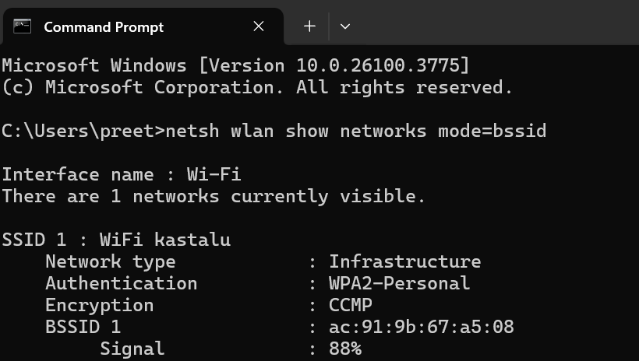

3 MATCHING ALGORITHM
The algorithm compares the scanned BSSID-RSSI list with fingerprints from every room using a signal distance formula. Only the BSSIDs common to both lists are considered to avoid noise from unrelated networks.
3.1 RSSI Matching Formula
The formula used to calculate the signal distance is:
$$Distance=\sqrt{\sum_{i=1}^{n}{{({RSSI }_{input,i }-{RSSI }_{fingerprint,i })}^{2}}}$$
This is essentially the Euclidean distance between the signal strength vectors. The fingerprint file with the lowest distance score is selected as the predicted location.
This is a simplified 1-nearest-neighbor approach without ML training.

3.2 Fingerprint Format and Matching Flow
Each fingerprint file (e.g., 301i.json, 302o.json) contains around 200 BSSID-RSSI pairs.
Example Matching Flow:
- User pastes their scan on the website.
- Flask receives the JSON and parses it.
- The backend compares the user data to each fingerprint file.
- The file with the smallest distance is returned as the location.

4 EVALUATION AND TESTING
We evaluated the system on the third floor of the building. The setup involved collecting data from:
- Rooms 301 to 308 (inside and outside)
- 200+ Wi-Fi scans per location
Testing was done using a second device (laptop or phone). This device was moved around the floor and its scan results were submitted via the Flask web interface.
The system successfully predicted the correct room in 90–95% of cases, depending on signal consistency.
Estimated accuracy:
- Within 1–3 meters
- Better in rooms with more distinct Wi-Fi coverage

📸 Screenshot 2 – Flask Server Running
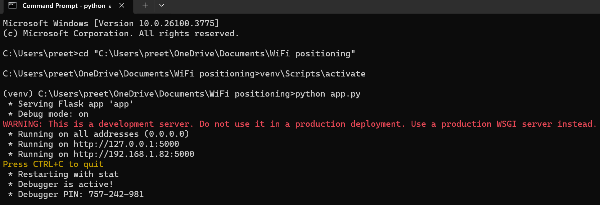

📸 Screenshot 3 – Input Web Page
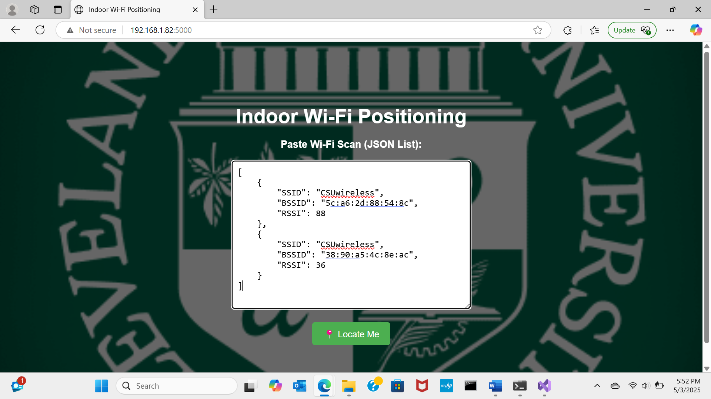

📸 Screenshot 4 – Output Web Page (Result)
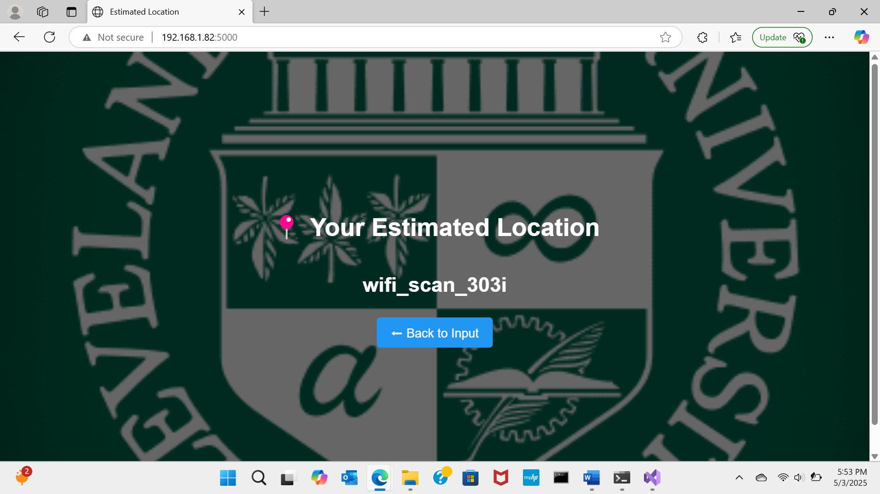

5 TEAM MEMBER CONTRIBUTIONS
- Murala Preethishivani
– Designed the system architecture, built the backend using Flask, collected and structured Wi-Fi fingerprints, and implemented the RSSI distance algorithm.
- Sahiti
– Developed the frontend using HTML/CSS, designed the user interface, and assisted in testing and validating the input/output flow.
- Nandini
– Focused on Wi-Fi data collection in various rooms, managed the formatting of fingerprint files, and helped verify the prediction accuracy during test runs.

6 CONCLUSION
This project demonstrates a practical indoor positioning system using Wi-Fi signal fingerprinting. The approach is fully browser-based and does not require GPS, Bluetooth, or new hardware. It uses existing infrastructure (Wi-Fi routers) and basic signal matching logic to achieve reliable room-level accuracy.
Advantages:
- Lightweight
- Deployable on laptops or mobile browsers
- Accurate with enough samples
Future Improvements:
- Add automated scanning via mobile apps (Android)
- Apply averaging of signals for smoother results
- Train ML models like KNN or Random Forest for better prediction
- Add heatmap visualization for analytics

7 REFERENCES
[1] Flask Documentation. https://flask.palletsprojects.com
[2] Microsoft Docs: netsh Commands for Wireless Local Area Network (WLAN).
[3] P. Bahl and V. Padmanabhan. “RADAR: An In-Building RF-based User Location and Tracking System.” Microsoft Research, 2000.
[4] IEEE 802.11 Wireless LAN Standard. https://standards.ieee.org

